Hypothesis: Testing whether there is an association between gender and living condition of persons in Ghana.

Joshua Owusu Ansah

Project

**Step 1: Making a claim**

Null Hypothesis(H0): There is no association between gender and the living condition of persons in Ghana.

Alternative Hypothesis (Ha): There is an association between gender and living condition of persons in Ghana.

**Step 2: Choosing of Sample and Summary of Data**

A random sample of 2146 Ghanaians are used to determine whether there is an association between gender and the living condition of persons in Ghana. Below is the table of count and proportion:

**Table of Count**

|  |  |  |  |
| --- | --- | --- | --- |
|  | **Females** | **Males** | **Totals** |
| **Bad** | 647 | 601 | 1248 |
| **Good** | 424 | 474 | 898 |
| **Totals** | 1071 | 1075 | 2146 |

Number of females: 1071 and number of males: 1075.

**Table of Proportion**

|  |  |  |
| --- | --- | --- |
|  | **Females** | **Males** |
| **Bad** | 0.6041 | 0.5591 |
| **Good** | 0.3959 | 0.4409 |

From the table of count, the criteria for the chi-square test is met:

* All the counts are greater than 5.

**Step 3: Accessing the evidence**

Chi-square test of independence.

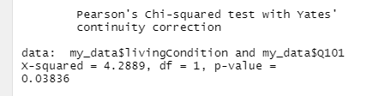

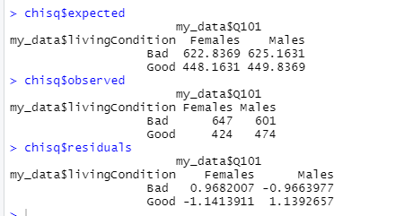

For the expected values, they are the values we will expect if there is no association between gender and living condition of persons in Ghana. On the other hands, the observed values are the values the real data shows. This shows that there is an association between gender and the living condition of persons in Ghana.

**Step 4: Making a conclusion**

Significance Level: 0.05

Decision Rule:

p-value<significance level (0.05)

Conclusion:

Since the significance level is greater than the p-value, there is enough evidence for us to reject the null hypothesis. Thus, the data support the claim that there is an association between gender and the living condition of persons in Ghana.

**Moderation**

Moderation by geographical area of respondent who said their living condition is good.

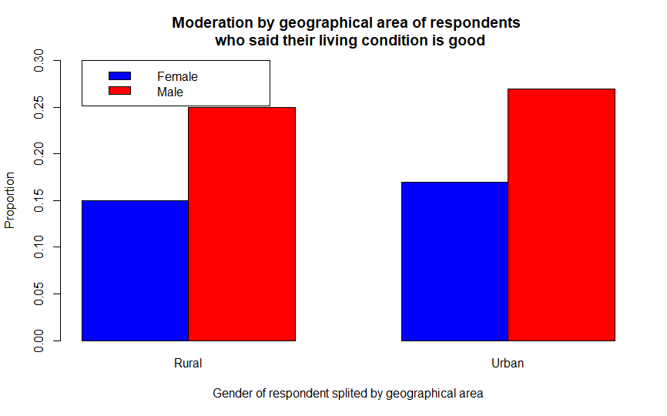

Moderation by geographical area of respondent who said their living condition is bad.

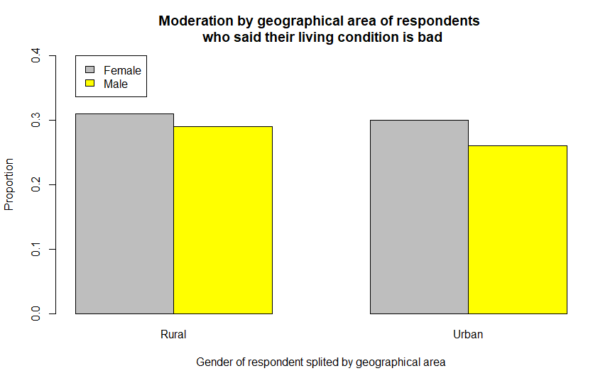

**Table of count and proportion**

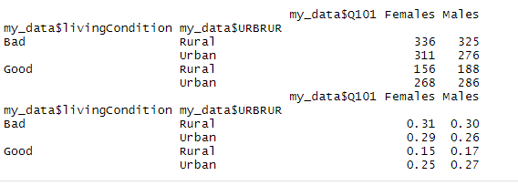

For the respondents who said their living condition is good, in rural area, there are more males than females (males= 17%, females=15%). Also, in the urban centers, there are more males whose living condition is good than that of females (males= 27%, female= 25%). But for those who said their living condition is bad we see another side of the coin. Thus, for those in rural areas, more of the females says their living condition is bad (female=31%, males=30%). The same results can be seen in the urban centers. Thus, there are more females alluding to the fact that their living condition is bad (females=29%, males=26%).

**General Conclusion**

In summary, the hypothesis that this research is focused on is checking whether there is an association between gender and the living condition of persons in Ghana. However, from the research a conclusion was drawn that indeed there is an association between gender and the living condition of persons in a country (answer-based on significance level being greater than the p-value). From the moderation, this makes intuitive sense. This is because, for those who said their living condition is good, in both the rural and urban areas, there were more males than females. Notwithstanding, those who said their living condition is bad, in both the rural and the urban centers, there were more females than males. So, the deductions that can be made from here is males have better living condition than that of the females. Indisputably, this claim can be said to be valid, in a sense that there was approximately equal representation of males and females used in the research (please refer to graph below). This even go a long way to affirm what we see in society today. Men are the people holding a significant number of influential positions which comes with huge salaries. So, their living conditions will be better than that of the females.

